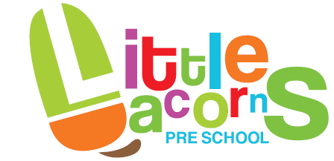
P.L.A. Membership No. 202255
Registered Charity No. 1185961

Furley Park Primary Academy, Reed Crescent, Ashford, TN23 3PA

Telephone: 01233 438809
E-mail: littleacorns1@btconnect.com
Web Site: www.littleacornsashford.com

Manager: Mrs Donna White

Nappy changing

Policy statement

No child is excluded from participating in our setting who may, for any reason, not yet be toilet trained and who may still be wearing nappies or equivalent. We work with parents towards toilet training, unless there are medical or other developmental reasons why this may not be appropriate at the time.

We provide nappy changing facilities and exercise good hygiene practices in order to accommodate children who are not yet toilet trained.

We see toilet training as a self-care skill that children have the opportunity to learn with the full support and non-judgemental concern of adults.

Procedures

- Key persons have a list of personalised changing times for the children in their care who are in nappies or ‘pull-ups’.
- Key persons undertake changing children in their key groups; ‘buddies’ change them if the key person is absent.
- Changing areas are warm with safe areas to lay children.
- Each child has their own changing bag to hand with their nappies or pull ups and changing wipes.
- Gloves are put on by staff before changing starts and the areas are prepared. Changing mats are cleaned with anti-bac spray between each nappy change.
- All staff are familiar with the hygiene procedures and carry these out when changing nappies.
- In addition, key persons ensure that nappy changing is relaxed and a time to promote independence in young children.
- Children are encouraged to take an interest in using the toilet; they may just want to sit on it and talk to a friend who is also using the toilet.
- Children are supported to wash their hands, and have soap and towels to hand.
- Anti-bacterial hand wash liquid or soap should not be used for young children; young skin is quite delicate and anti-bacterial products kill off certain good bacteria that children need to develop their own natural resistance to infection.
- Key persons are gentle when changing; they avoid pulling faces and making negative comments about ‘nappy contents’.
- Key persons do not make inappropriate comments about children’s genitals when changing their nappies.
- Older children access the toilet when they have the need to and are encouraged to be independent.
- Nappies and pull ups are disposed of hygienically, bagged and put in the bin. Cloth nappies, trainer pants and ordinary pants that have been wet or soiled are bagged for the parent to take home.
- We have a duty of care towards children’s personal needs. If children are left in wet or soiled nappies/pull ups in the setting this may constitute neglect and will be a disciplinary matter.

This policy was first adopted:

Date for review:

This policy was reviewed:

Signed:

Date:

